**UK Workbook**

DATA VISUALIZATION FINAL PROJECT

**Presented by**

# AFTAB NAFEES

# **GitHub Username**

# aftab1038

# **Repository Link**

# <https://shorturl.at/CQYyc>

# **Tableau Public Link**

# https://shorturl.at/aD2eS

**Table of Contents**

Introduction 03

Bar Chart: City with Count of Jobs (2011) 04

Tree map: Industry-Wise Jobs in 2011 06

Bubble Chart: Top 10 Industry by Jobs in 2014 08

Map Visualization: Job Count by City (UK) 10

Pie Chart: Sum of Industry Jobs in 2011 12

Dashboard: Job Changes in Industries 2011–2014 14

Conclusion 16

**Introduction**

**Dataset Overview**

The dataset titled **EMSI Job Change UK** provides detailed employment data for different cities across the UK from 2011 to 2014. It includes fields like:

* **City** and **Country**: Geographic location.
* **SIC Code**: Standard Industry Classification code representing various sectors.
* **Industry**: Description of each sector.
* **Jobs 2011** and **Jobs 2014**: The number of jobs in each industry in 2011 and 2014.
* **Change**: The absolute difference in job numbers between 2011 and 2014.
* **% Change**: The relative percentage change in job numbers over this period.

**Number of Rows**: This dataset contains around **1500** rows

#### **Objectives:**

The primary goal of the exploratory data analysis (EDA) is to uncover trends in job growth or decline across different industries and cities. Insights gained will serve as input features for future AI/ML models predicting job trends, workforce development, or economic forecasting.

**Bar Chart: City with Count of Jobs (2011)**

#### **Description:**

This horizontal stacked bar chart displays the number of jobs in 2011 across various industries for different cities in the UK. Each city is represented on the Y-axis, and the count of jobs is shown on the X-axis. The bars are color-coded based on different industries, as indicated in the legend on the right.

#### **Breakdown:**

* **Columns**: The chart sums up the number of jobs for each city from 2011 (SUM (Jobs 2011)).
* **Rows**: The cities are listed vertically (City field).
* **Color**: The industries are represented by distinct colors, making it easy to distinguish between sectors like **Education**, **Manufacturing**, **Health**, etc.

#### **Insights:**

* **Top Cities**: Newcastle-Sunderland, London, and Bristol have the highest number of jobs in 2011, with significant representation across diverse industries.
* **Industries**: Certain industries dominate specific cities. For example, cities like London and Birmingham show strong representation across most industries, while other cities might have more concentrated industries (such as mining and quarrying in some regions).

#### **Purpose:**

This visualization allows us to compare the employment distribution across different UK cities, helping identify key cities for industries. Insights like these will assist future AI/ML tasks in understanding geographic trends and how job concentration varies across industries and locations.

#### **Design Choice Justification:**

* **Stacked Bar Chart**: Ideal for showing part-to-whole relationships, where we can see both the total number of jobs and the breakdown by industry.
* **Color Coding**: The distinct color palette for industries allows quick differentiation, making the data visually clear and easy to interpret.
* **Sorted by City**: The cities are ordered by total job count, highlighting which cities are more significant in terms of employment.

**Bar Chart:**

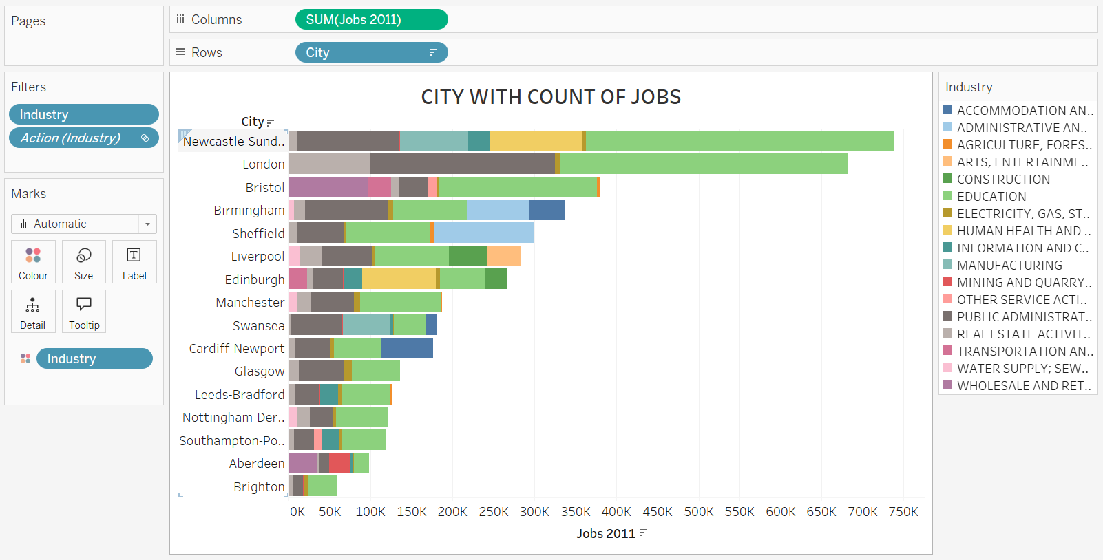

**Tree map: Industry-Wise Jobs in 2011**

**Description:**

This **tree map** visualization shows the distribution of jobs across different industries in 2011. The size of each block represents the total number of jobs in a particular industry, allowing for quick comparison between industries.

**Breakdown:**

* **Columns/Rows**: There are no specific rows or columns in this chart, as the treemap organizes data hierarchically based on the sum of jobs per industry.
* **Color and Size**: Each industry is represented by a colored block, with the size proportional to the number of jobs in 2011. Larger blocks indicate industries with a higher job count.

#### **Key Insights:**

* **Dominant Industry**: The **Education** sector is the largest industry in 2011, taking up the largest portion of the tree map.
* Other significant industries include **Human Health and Social Work Activities**, **Real Estate Activities**, and **Public Administration and Defense**.
* **Wholesale and Retail Trade** and **Construction** industries also have noticeable representation, though their blocks are smaller compared to the others.

**Purpose:**

This tree map provides a high-level overview of how jobs are distributed across different industries, with a focus on identifying the largest sectors. This type of visualization helps in understanding which industries are major employers, which is valuable for AI/ML tasks like workforce prediction or economic forecasting.

**Design Choice Justification:**

* **Tree map Layout**: This is an effective choice for comparing proportions between different categories (industries), especially when space is limited. The tree map layout allows for a clear visual comparison of the relative sizes of the industries.
* **Color-Coding**: While all industries are given a distinct color, the differentiation in sizes is what stands out, providing clarity on the job concentration across industries.
* **Labeling**: The labels inside each block give a clear indication of the industry name, making it easy to identify the largest and smallest industries.

**Potential Enhancements:**

* Adding interactivity (such as tooltips) to display more detailed information when hovering over each block.
* Filtering by year or region could help further refine the insights for decision-making

**Tree Map:**

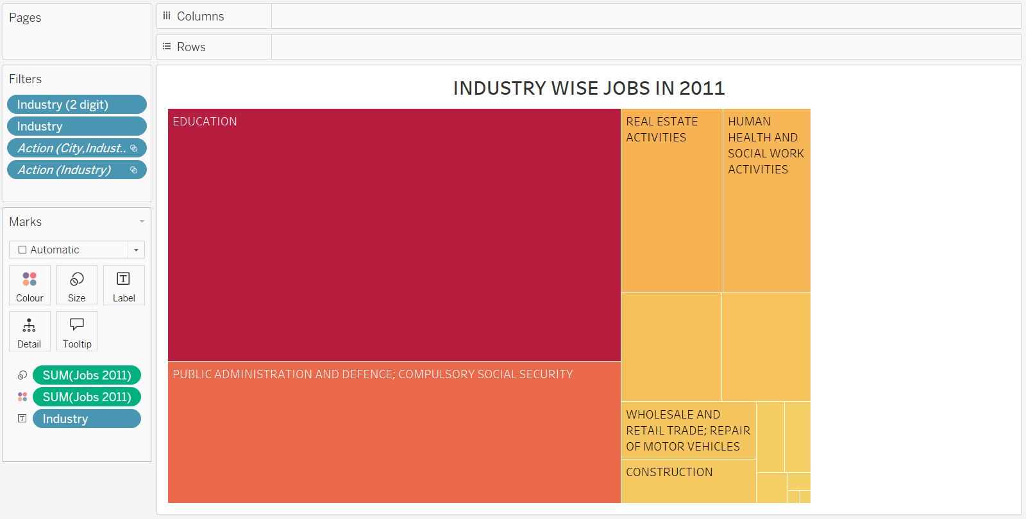

**Bubble Chart: Top 10 Industry by Jobs in 2014**

#### **Description:**

This **bubble chart** shows the top 10 industries in 2014 based on the number of jobs. Each bubble represents an industry, and the size of the bubble corresponds to the number of jobs in that industry. The color coding is based on different industries, as indicated by the legend.

#### **Breakdown:**

* **Bubble Size**: The size of each circle reflects the number of jobs in that industry in 2014. Larger bubbles indicate industries with a higher job count.
* **Color**: Each industry is colored based on its sector, making it easier to distinguish between industries.

#### **Key Insights:**

* **Dominant Industry**: Similar to the previous years, **Education** is the largest industry in 2014, represented by the largest green bubble.
* Other significant industries include **Public Administration and Defense**, **Human Health and Social Work Activities**, and **Real Estate Activities**, which are reflected by relatively large bubbles.
* Smaller industries such as **Wholesale and Retail Trade**, **Information and Communication**, and **Construction** are present but have smaller job counts compared to the major sectors.

#### **Purpose:**

The bubble chart highlights the major industries in terms of job numbers, allowing quick identification of the largest employers in the economy. This is useful for AI/ML tasks aimed at forecasting workforce demand or understanding industry-specific growth patterns.

#### **Design Choice Justification:**

* **Bubble Chart**: This is a good choice for visualizing relative size differences across categories. The circular design naturally draws the eye to the largest categories, making the most important industries easy to spot.
* **Color-Coding**: Each bubble is distinctly colored based on the industry, making it visually clear and easy to differentiate between industries.
* **Size Emphasis**: The use of bubble size to represent job count emphasizes the importance of each industry, with larger industries visually dominating the chart.

#### **Potential Enhancements:**

* Adding hover-over tooltips for more precise details (exact job numbers) could make this chart more informative.
* Implementing a time-slider or filter for different years would allow for dynamic analysis, showing how industries grow or shrink over time.

**Bubble Chart:**

**Map Visualization: Job Count by City (UK)**

**Description:**

This map visualization represents the distribution of job counts across various cities in the United Kingdom. Each city is marked by a dot, where the color intensity and size of the dot indicate the magnitude of job change (increase or decrease) between 2011 and 2014.

**Breakdown:**

* **Columns & Rows:** The chart uses latitude and longitude to position the cities accurately on the map.
* **Color:** The color gradient from orange to red represents the sum of job changes, with orange indicating smaller changes and red indicating more significant changes.
* **Size:** The size of the dots corresponds to the magnitude of job changes in each city, with larger dots indicating higher job changes.

**Key Insights:**

* **Major Cities:** The map shows that cities in southern England, particularly around London, exhibit significant job changes, as indicated by larger and darker dots.
* **Geographic Distribution:** There is a clear concentration of job changes in the southern part of the UK, with some notable changes in northern cities like Manchester and Leeds.
* **Regional Patterns:** The map also allows for the identification of regional job growth or decline, helping to spot areas of economic activity or stagnation.

**Purpose:**

The primary purpose of this map visualization is to provide a geographic overview of job distribution and changes across UK cities. It helps in understanding regional economic shifts and can be instrumental in identifying areas that may require policy intervention or investment.

**Design Choice Justification:**

* **Map Visualization:** A map is ideal for this type of geographic data, allowing for a clear and immediate understanding of spatial distribution and regional trends.
* **Color Gradient:** The use of a color gradient from orange to red effectively conveys the intensity of job changes, making it easy to spot areas of significant economic activity.
* **Dot Size:** The varying sizes of the dots add another layer of information, allowing users to quickly assess which cities have experienced the most significant job changes.

**Potential Enhancements:**

* **Interactivity:** Adding interactive features, such as tooltips that show exact job change numbers when hovering over a city, could provide more detailed insights.
* **Filters:** Implementing filters for specific industries or years could help users focus on particular aspects of the data, enhancing the utility of the map for different analytical purposes.

**Map Visualization:**

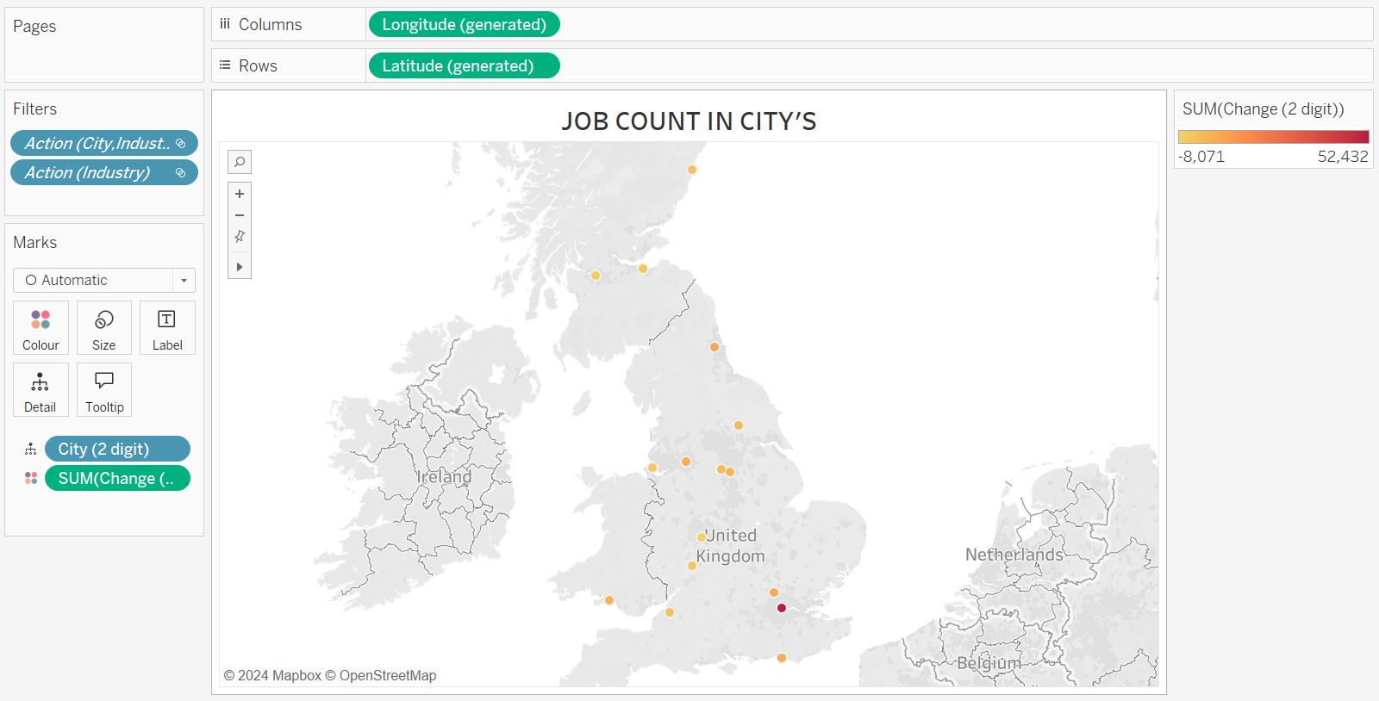

**Pie Chart: Sum of Industry Jobs in 2011**

**Description:**

This pie chart represents the distribution of jobs across various industries in the year 2011. Each segment of the pie represents a specific industry, with the size of the segment indicating the total number of jobs in that industry.

**Breakdown:**

* **Center Data Labels:** The numbers in the center of the chart show the job totals for selected industries. For example, the construction industry is highlighted with 1,469,549 jobs, which makes up the largest segment in the chart.
* **Industry Legend (Right):** The chart uses different colors to represent various industries, as listed on the right. Industries include:
  + **Construction (Green)**
  + **Public Administration (Dark Gray)**
  + **Manufacturing (Orange)**
  + **Education (Light Gray)**
  + **Real Estate (Light Blue**)

**Key Insights:**

* **Dominant Industries:** The construction industry holds the largest share of jobs in 2011, as indicated by its large green segment.
* **Other Major Contributors:** Public administration and defense, education, and manufacturing also hold significant shares of jobs.
* **Smaller Industries:** Some industries, such as mining and quarrying, real estate, and water supply, have relatively smaller shares of jobs.

**Purpose:** The primary purpose of this pie chart is to give a quick overview of the job distribution across industries in 2011. It helps users understand which sectors were the largest employers and how jobs were spread out across different industries.

**Design Choice Justification:**

* **Pie Chart:** A pie chart is a suitable visualization for this data as it clearly shows the proportion of jobs in each industry relative to the total.
* **Color Coding:** The use of distinct colors for each industry allows for easy identification and comparison of job distribution among industries.

**Potential Enhancements:**

* **Exact Percentages:** Adding percentage labels to each segment would provide more precise insight into the relative share of each industry.
* **Comparative Year Data:** Including data from another year, such as 2014, in a side-by-side comparison could help analyze job growth or decline across industries.

**Pie Chart:**

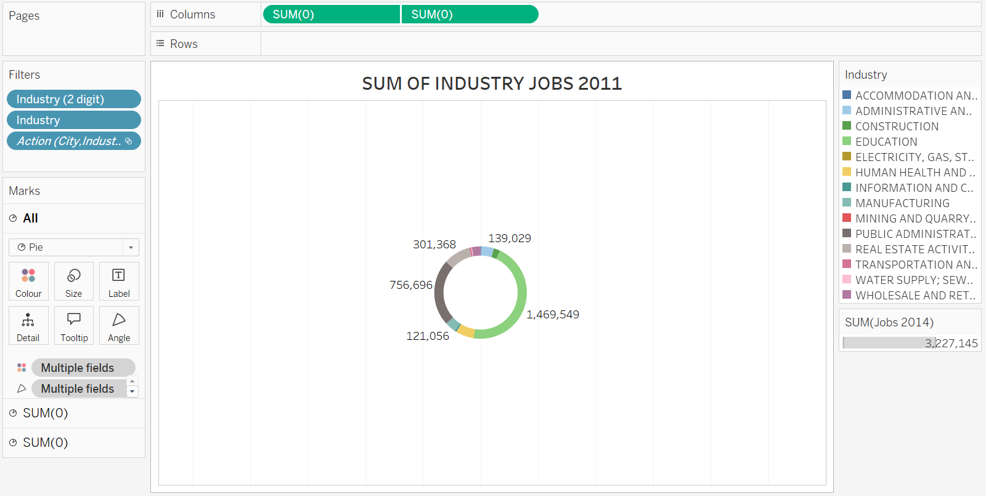

**Dashboard: Job Changes in Industries 2011–2014**

**Overview:**

This dashboard provides a comprehensive overview of job changes across various industries and cities in the United Kingdom between 2011 and 2014. It uses different visualizations to depict the distribution and change in job counts by city and industry.

**Key Sections of the Dashboard:**

**1. City with Count of Jobs (Bar Chart):**

* Displays the number of jobs in key UK cities in 2011. Each bar is color-coded based on industry.
* Cities like London, Birmingham, and Manchester have the highest job counts.
* The bars show a breakdown of job distribution across different industries, using colors representing industries from the legend on the right.

**2. Industry-Wise Jobs in 2011 (Tree map):**

* A tree map visualization shows job distribution across industries in 2011.
* **Education**, **Public Administration and Defense**, and **Real Estate** are the largest sectors, represented by the largest rectangles.
* Other industries, such as **Manufacturing**, **Construction**, and **Health**, are also visible in various sizes, indicating their relative contribution to job counts in 2011.

**3. Sum of Industry Jobs in 2011 (Pie Chart):**

* A circular pie chart shows the sum of industry jobs in 2011.
* **Construction** leads with 1,469,549 jobs, followed by **Public Administration** (756,696 jobs) and **Education** (301,368 jobs).
* Smaller sectors, such as **Mining** and **Water Supply**, have much smaller shares.

**4. Top 10 Industry by Jobs in 2014 (Bubble Chart):**

* This bubble chart highlights the top 10 industries with job counts in 2014.
* **Education** dominates, represented by the largest bubble.
* Other significant industries include **Public Administration** and **Real Estate**, while smaller bubbles represent industries like **Information Technology** and **Manufacturing**.

**5. Job Count in Cities (Map):**

* A geographical map shows the job distribution across cities in the UK.
* The dots on the map are color-coded according to job count, with the red dots representing higher job numbers.
* London has a high concentration of jobs, as indicated by the red dot, while other cities show varying sizes of yellow/orange dots.

### **Usage:**

This dashboard provides a detailed analysis of job distribution across cities and industries, helping businesses, policymakers, and analysts understand employment trends over time. It highlights key sectors contributing to employment growth and regional job distributions.

**Dashboard:**

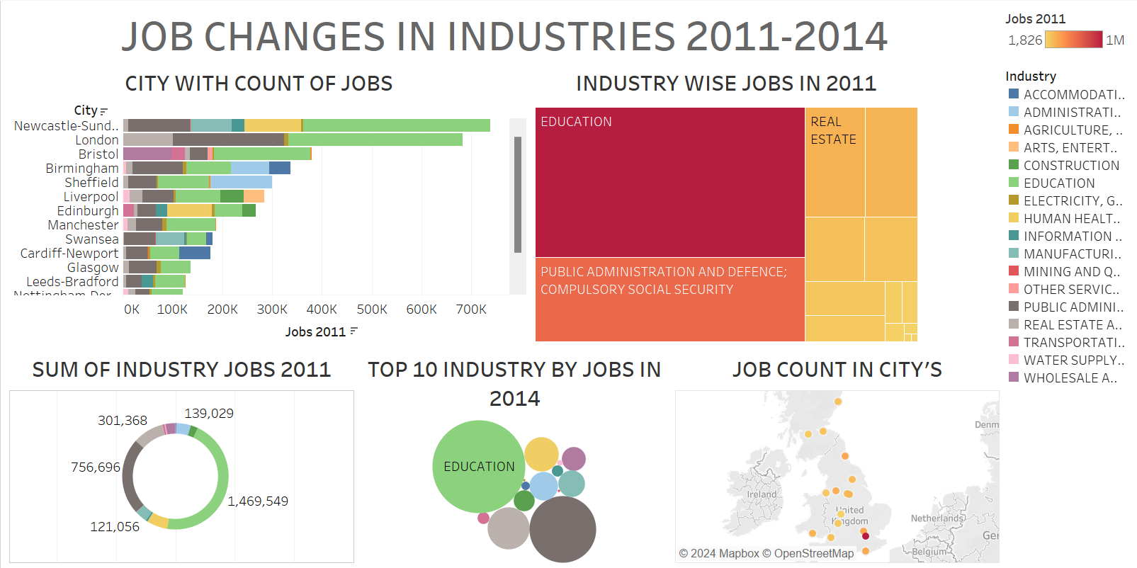

**Conclusion**

The 2011–2014 period shows that while certain industries and cities flourished, there are clear disparities in job distribution across regions and sectors. Going forward, both policymakers and business leaders should focus on fostering growth in underrepresented regions and industries while ensuring that the workforce is equipped to adapt to changing economic demands.